

School of InfoComm Technology

Data Virtualization
Diploma in Data Science (DS)
2025 Oct Semester

INDIVIDUAL ASSIGNMENT
(40% of Module)

09 Jan 2026 – 01 Feb 2026

Deadline for Submission:
Denodo Database File, Report and PowerPoint Slides: 01 Feb 2026 (Sun), 2359hrs

Student Name | : | Ang Shao En
Student Number | : | S10267887D

Penalty for late submission:
10% of the marks will be deducted every day after the deadline.
NO submission will be accepted after 08 Feb 2026, 23:59.

Table of Contents
Contents
School of InfoComm Technology 1
Table of Contents 2
1. Introduction with Value Based Problem Statement 4
2. Data Sources and Base Views 6
Creating Data Sources 7
Rationale for Data Source Selection 8
Creating Base Views 9
Data Type Standardization 9
Rationale for Clean Base Views 11
3. Feature Engineering and Derived/Integrated Views 12
iv_orders_enriched(Order-level context) 13
iv_orders_enriched_features (Time feature engineering) 15
iv_order_items_enriched (Product/brand/category enrichment at item grain) 17
iv_order_items_revenue (Financial KPI engineering) 19
iv_sales_fact (Unified analytic dataset) 20
Why was the feature engineering done in the Final Reporting View (RV) instead of the Integrated Views (IV)? 22
4. Final Integrated View 23
Contributing Source Files 23
Why All Seven Files? 23
Aggregation Design (Grain) 23
Key Performance Indicators (KPIs) 24
Formula Design Rationale 25
How These KPIs Answer the Exploratory Questions 25
5. REST or SOAP Deployment 27
Why REST over SOAP? 27
Business & Stakeholder Context 27
REST Service Configuration 27
Security Configuration 28
Service Deployment 29
Testing and Validation 29
Deployment Outcome 30
6. Summary and Further Improvements 31
Summary of Achievement 31
Key Learning Outcomes 31
Further Improvements 32
Conclusion 32

This report documents the end to end development of a virtualised sales reporting solution using Denodo. It begins with a value based problem statement and stakeholder needs, followed by a description of the underlying CSV data sources and the base views created to standardise each dataset. Next, it explains how integrated views and engineered measures were designed to combine orders, order items, product, store, category, and customer information into business ready datasets. The report then presents the final reporting view, including the grouping dimensions and calculated performance metrics used to analyse revenue, order volume, units sold, and discount impact across time and organisational dimensions. Finally, the report demonstrates how the final RV is deployed as a REST web service to enable lightweight consumption by downstream applications and stakeholders, and concludes with reflections and recommendations for further improvements.

1. Introduction with Value Based Problem Statement
In today’s competitive retail environment, decision-makers require timely, accurate, and integrated information to understand sales performance and customer purchasing behaviour across multiple business dimensions. In the case of a bicycle retail company operating across multiple stores, locations, brands, and product categories, sales information is typically distributed across operational datasets such as orders, order items, product catalogues, store records, and customer data. When these datasets are analysed in isolation, it becomes difficult to produce a consistent and holistic view of business performance. This fragmentation increases reliance on manual data extraction, introduces inconsistency in KPI calculations, and slows both operational responses and strategic decision-making.
The primary stakeholders for this use case are store managers, sales operations teams, and product managers. Store managers require store and location level visibility to compare performance across cities and states, identify high performing product categories, and track monthly trends in demand. Sales operations teams need reliable, aggregated metrics to evaluate revenue outcomes and quantify the impact of discounting over time. Product managers require consistent brand and category level performance insights to adjust assortment, merchandising, and promotional strategies across the retail network. Although these stakeholders rely on the same transactional foundations, they require the data to be presented in a consistent, business ready reporting forma.
The value based problem addressed in this assignment is the lack of a unified sales performance reporting view that consolidates transactional sales activity into standardized monthly KPIs across store, location and product segment dimensions, supported by customer activity measures. Without this integrated reporting layer, stakeholders cannot efficiently benchmark stores, monitor seasonal patterns, or evaluate how discounts influence revenue outcomes in a consistent way. Traditional approaches that physically consolidate data into a warehouse can be resource intensive and inflexible when reporting requirements evolve. Using Denodo, this solution applies data virtualization to standardise and integrate the required datasets into reusable views, producing a single reporting view that supports faster self service analysis and consistent decision making without heavy data movement.

Exploratory Questions:
To ensure the virtualized dataset delivers meaningful business value, the following exploratory questions guide the design of the views:
- Which product categories and brands generate the highest net revenue, and how does this vary across stores and locations?
- How does sales performance differ across stores and over time in terms of net revenue, orders, and units sold?
- What is the impact of discounting on revenue outcomes across categories, brands, and stores over time?
- Which brands contribute most significantly to overall sales performance, and are there clear geographic or store-level differences in brand performance?
- How do customer purchasing patterns, such as customer volume, orders per customer, and net revenue per customer vary across product categories, brands, and stores?
These exploratory questions directly inform the selection of data sources, the design of base and integrated views, and the structure of the final reporting view, ensuring the virtualized solution remains aligned with stakeholder needs and business objectives.

2. Data Sources and Base Views
This assignment uses seven CSV files representing the bicycle retailer's core operational entities: brands, categories, customers, orders, order_items, products, and stores. These files were first placed into the Denodo lab environment to ensure consistent access and repeatability during development.

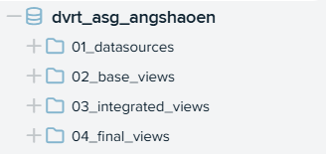
Figure 1. Denodo database and folder structure for the assignment

A dedicated Denodo database (dvrt_asg_angshaoen) was created with a clear folder structure to separate:
- 01_datasources – CSV data source connections
- 02_base_views – Standardized base views
- 03_integrated_views – Derived and joined views
- 04_final_views – Final reporting view
- 05_data_service – REST/SOAP deployment

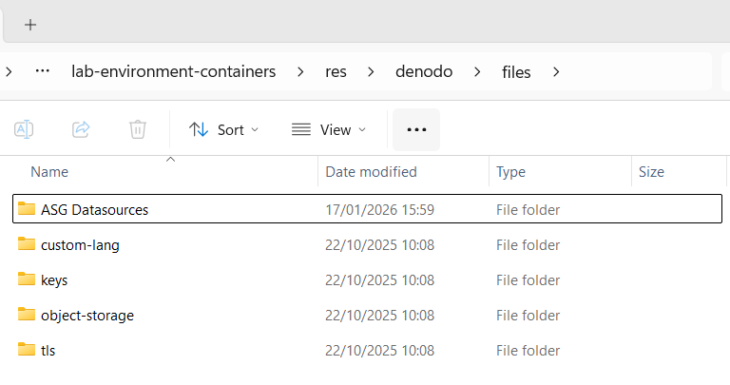
Figure 2. Assignment CSV files placed into the Denodo lab environment folder

Creating Data Sources
Each CSV was registered as a datasource (ds_*) using Denodo's flat file connector. During loading, key file settings such as delimiter/encoding and header detection were verified to prevent schema misreads.

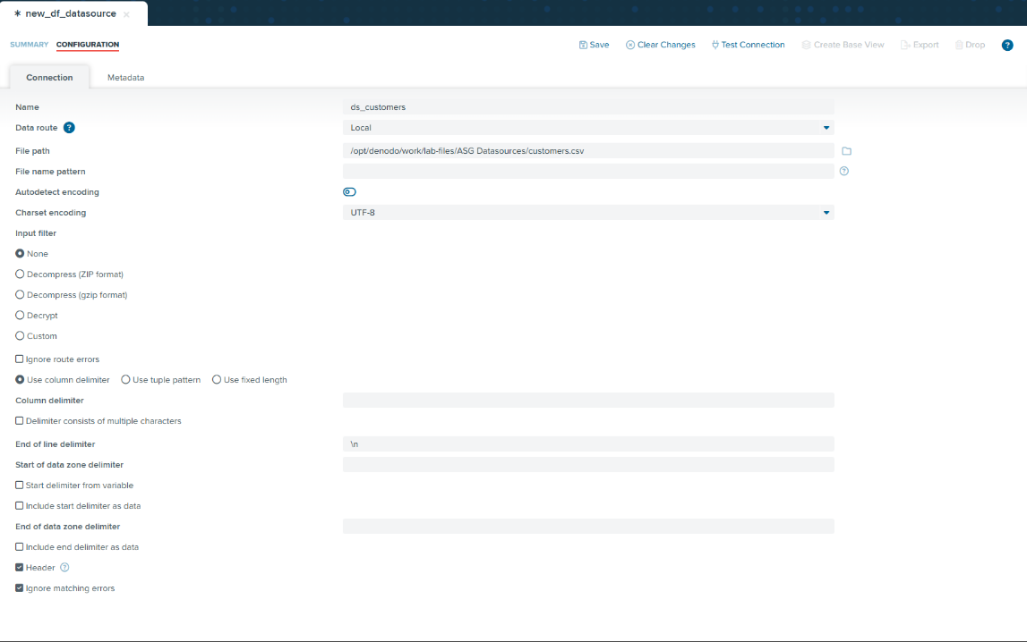
Figure 3. Creating a CSV datasource in Denodo (example configuration for customers.csv)

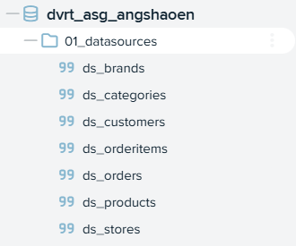
Figure 4. CSV data sources created in Denodo

Rationale for Data Source Selection
While the assignment requires a minimum of five data sources, I selected seven out of nine available CSV files to comprehensively address the value-based problem statement. The chosen files and their strategic justification are:
Core Transaction Layer (Essential for revenue analysis)
- orders.csv - Captures order-level metadata (order date, status, shipping dates) required for temporal analysis and processing time calculations
- order_items.csv - Contains item-level transaction details (quantity, price, discount) essential for accurate revenue calculations
- products.csv - Provides product attributes (list price, brand, category) needed for segment-level performance analysis
Organizational Dimensions (Required for multi-dimensional analysis)
- stores.csv - Enables store-level performance comparison as required by store manager stakeholders
- brands.csv - Supports brand performance analysis across geographic locations
- categories.csv - Allows category-level revenue aggregation for product manager decision-making
Customer Intelligence (Addresses customer behavior questions)
- customers.csv - Contains customer demographic and location data necessary for geographic analysis and customer segmentation metrics (orders per customer, revenue per customer)
Excluded Files and Justification:
- staffs.csv - Not relevant to sales performance analysis; human resources data outside scope of revenue/customer analytics problem statement
- stocks.csv - Inventory data valuable for future enhancement but not required for initial revenue performance reporting objectives
This selection ensures all five exploratory questions can be comprehensively answered while maintaining focus on the core problem: unified sales performance reporting across store, location, and product dimensions.

Creating Base Views
From each datasource, a corresponding base view (bv_*) was created. These base views standardize naming and expose only the relevant attributes needed for downstream joins and analysis.
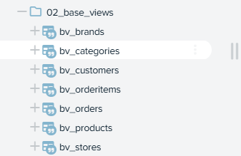
Figure 5. Base views created from each datasource (bv_*)

Data Type Standardization
After creating each base view, I reviewed the inferred schema and applied datatype standardization so that joins, aggregations, and downstream calculations behave correctly.

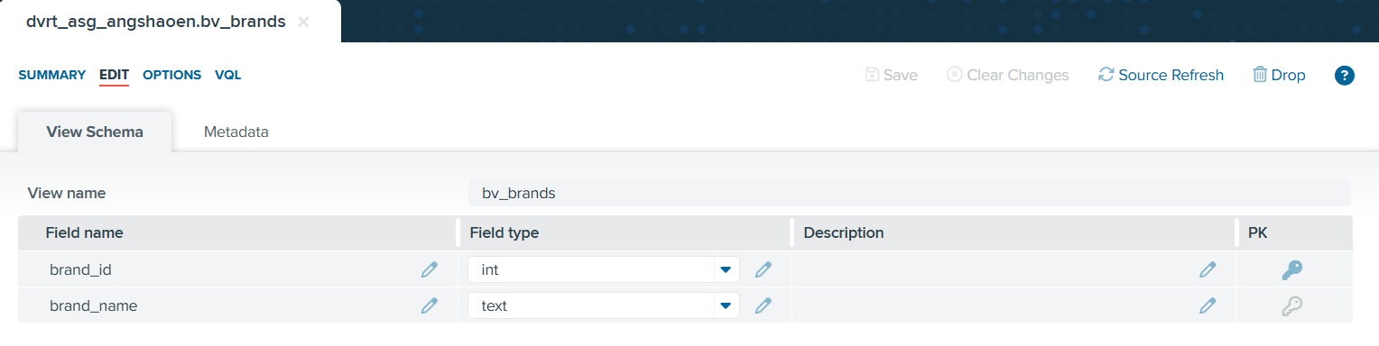
Figure 6. Base view schema: bv_brands

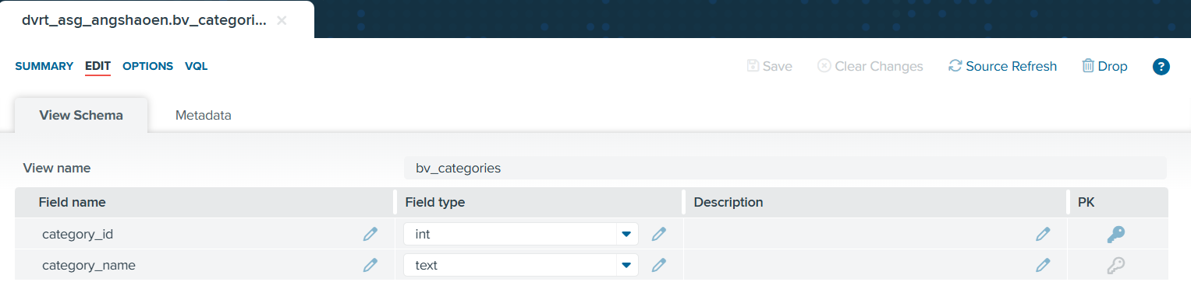
Figure 7. Base view schema: bv_categories

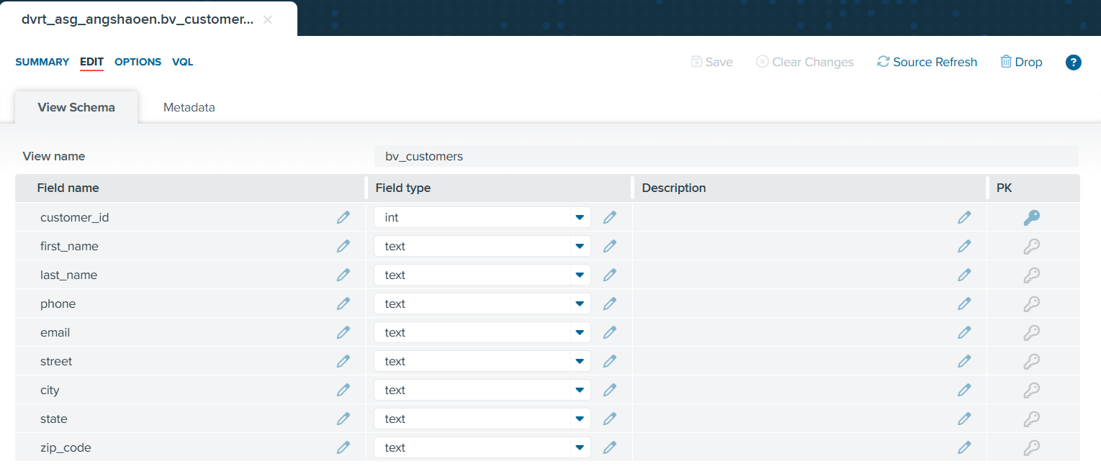
Figure 8. Base view schema: bv_customers

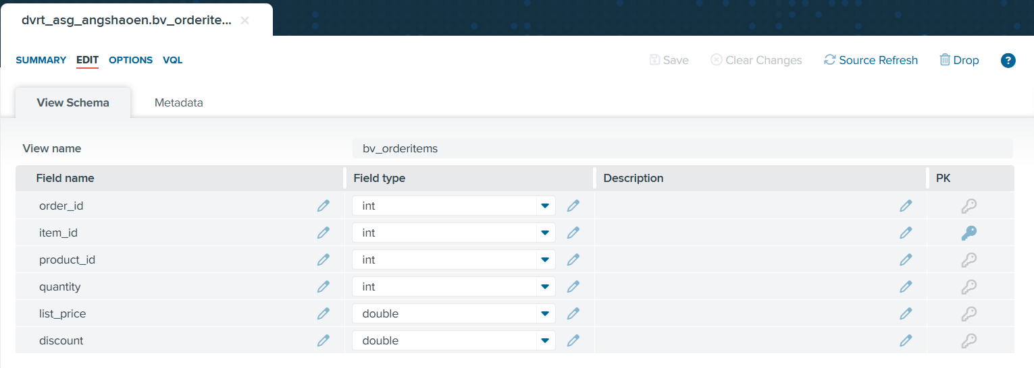
Figure 9. Base view schema: bv_orderitems

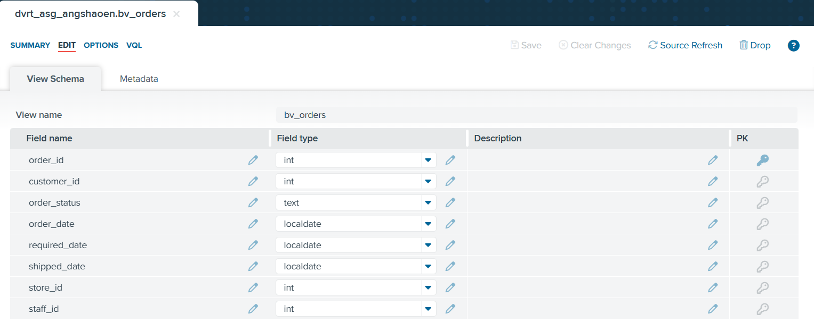
Figure 10. Base view schema: bv_orders

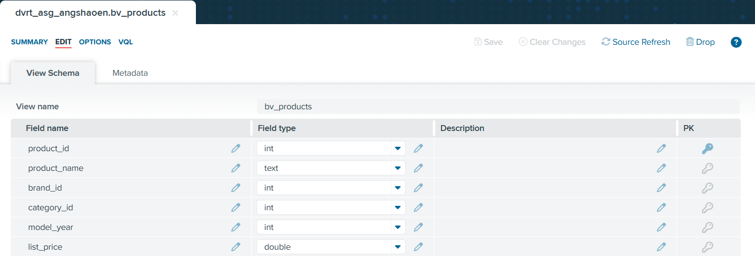
Figure 11. Base view schema: bv_products

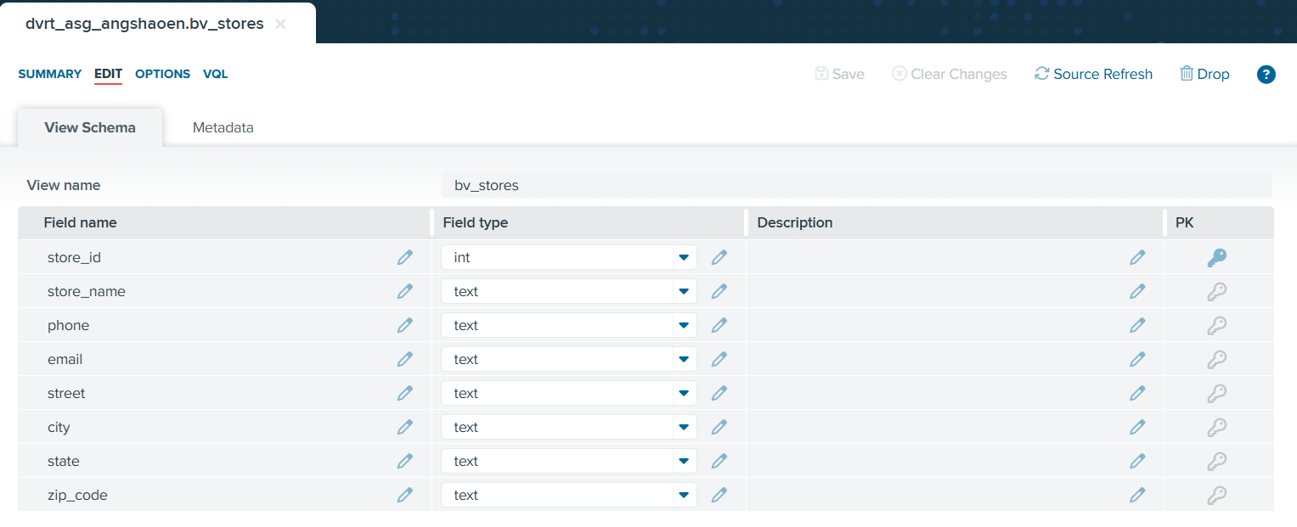
Figure 12. Base view schema: bv_stores

Rationale for Clean Base Views
Establishing clean base views is critical because the later integrated views depend on consistent keys (e.g., order_id, product_id, category_id, store_id, customer_id). This approach reduces repeated data preparation, improves traceability, and ensures the final report can be generated consistently even as reporting requirements evolve.

3. Feature Engineering and Derived/Integrated Views
To answer the exploratory questions, the base views were combined into a set of integrated views that progressively add business context and derived measures. This layered approach improves traceability and reusability.

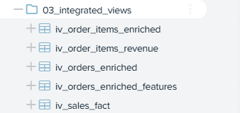
Figure 13. Overview of Integrated Views

iv_orders_enriched(Order-level context)
This view standardises the dataset to the order-level grain by joining order transactions (bv_orders) with customer and store dimensions using customer_id and store_id. Left outer joins are used to preserve orders even when some dimension attributes may be missing, ensuring completeness for reporting and preventing unintended record loss. This integrated layer provides the store/location and customer context needed for store comparisons and customer behaviour analysis.

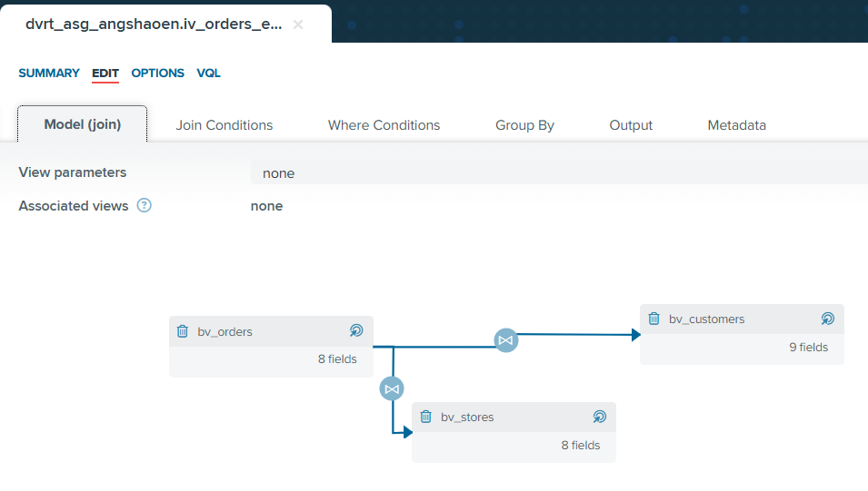
Figure 14. Join model for iv_orders_enriched

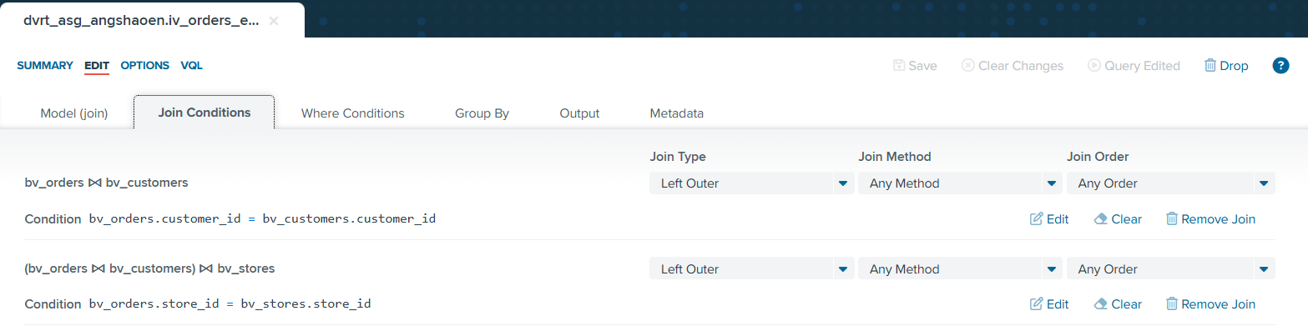
Figure 15. Join conditions for iv_orders_enriched

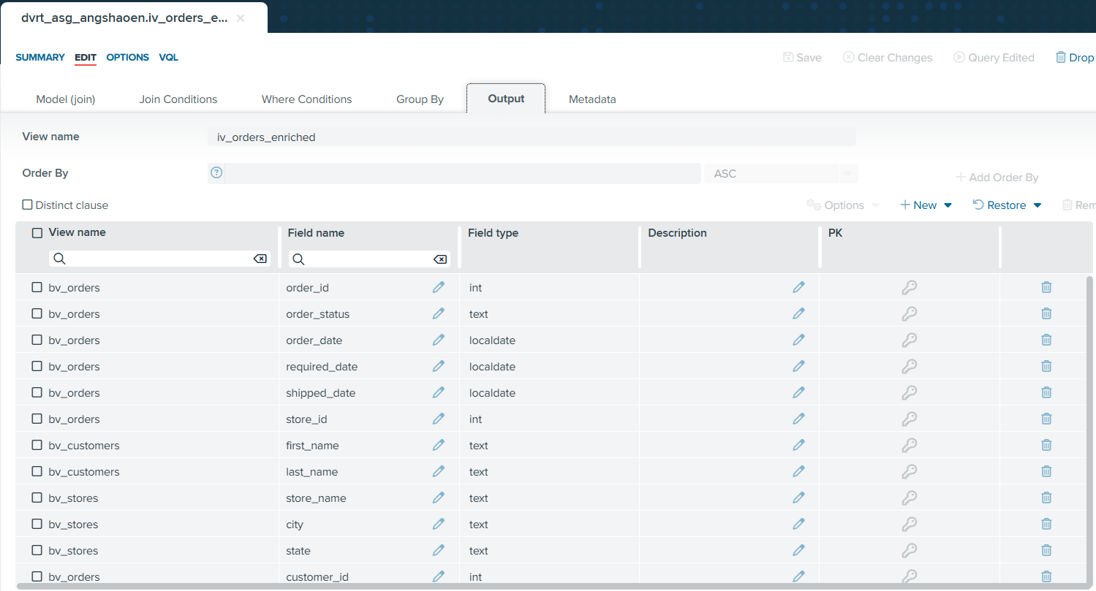
Figure 16. Final output for iv_orders_enriched

iv_orders_enriched_features (Time feature engineering)
This view derives consistent time features from order_date, specifically order_year and order_month. Engineering these fields once at the integrated layer ensures all downstream reporting uses the same logic for trend and seasonal analysis, without repeatedly recalculating date parts in later steps.


Figure 14. Join model for iv_orders_enriched


Figure 15. Join conditions for iv_orders_enriched


Figure 16. Final output for iv_orders_enriched

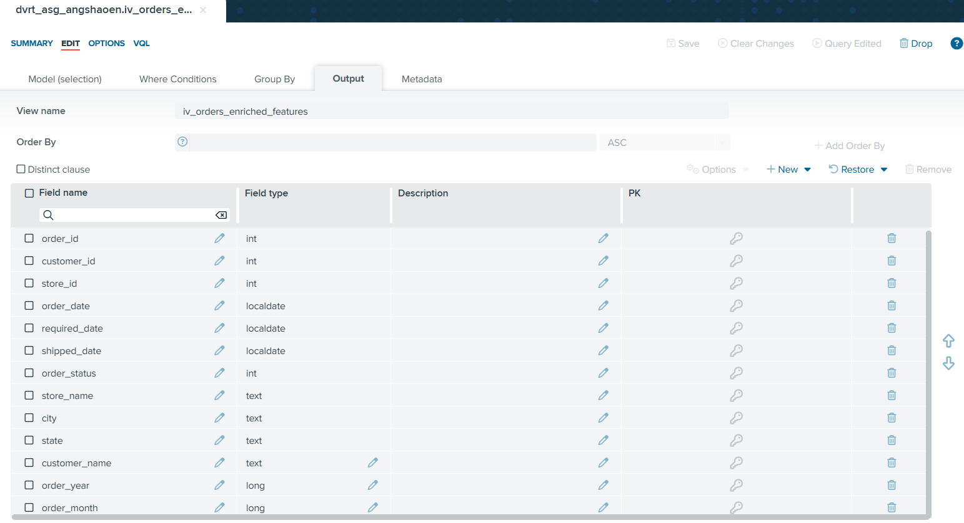
Figure 17. Final output for iv_orders_enriched_features

iv_order_items_enriched (Product/brand/category enrichment at item grain)
To analyse sales by product segments, order item transactions (bv_orderitems) are enriched with product attributes using product_id, and linked further to brand and category through the product-related keys. This converts operational item rows into business-ready item records that are analyzable by brand and category.
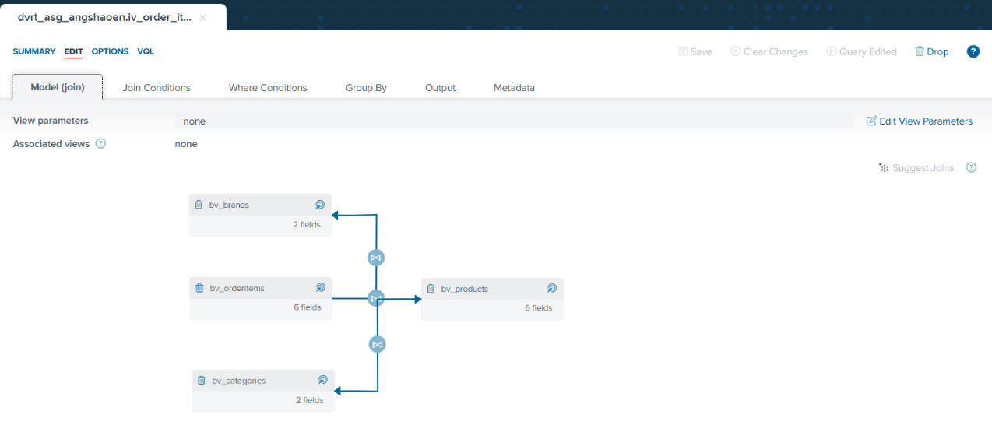
Figure 18. Join model for iv_order_items_enriched

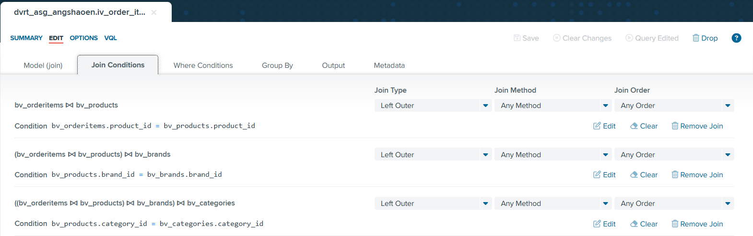
Figure 19. Join conditions for iv_order_items_enriched

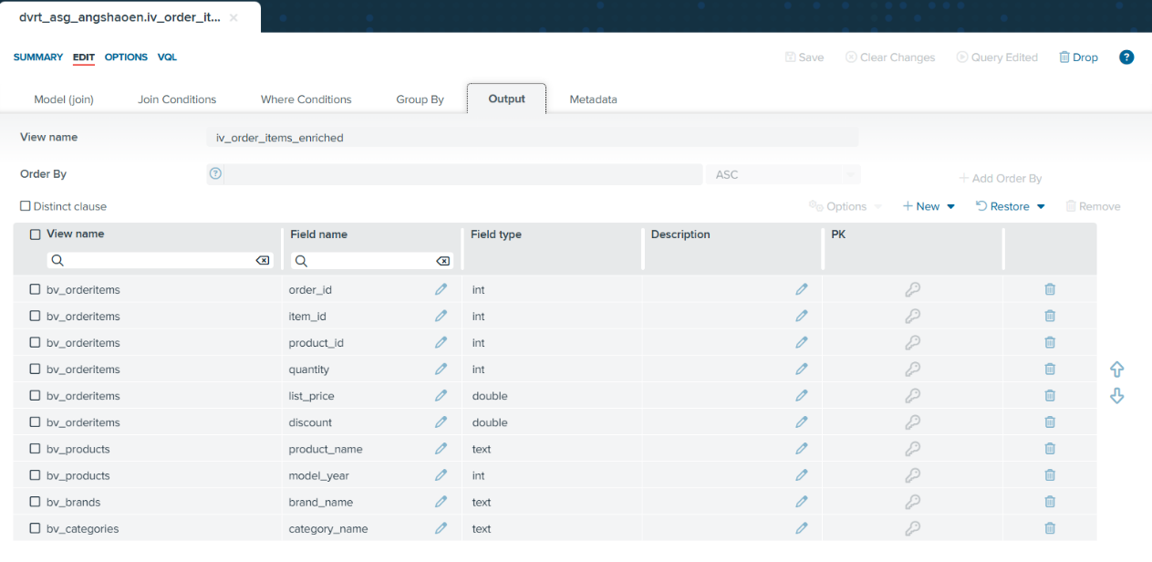
Figure 20. Final output for iv_order_items_enriched

iv_order_items_revenue (Financial KPI engineering)
This view engineers the core financial measures required for discount and revenue analysis. Calculating these measures at the item level ensures accuracy before aggregation:
- gross_revenue = quantity × list_price
- discount_amount = gross_revenue × discount
- net_revenue = gross_revenue − discount_amount
These measures directly support discount impact analysis and ranking of high-performing product segments.

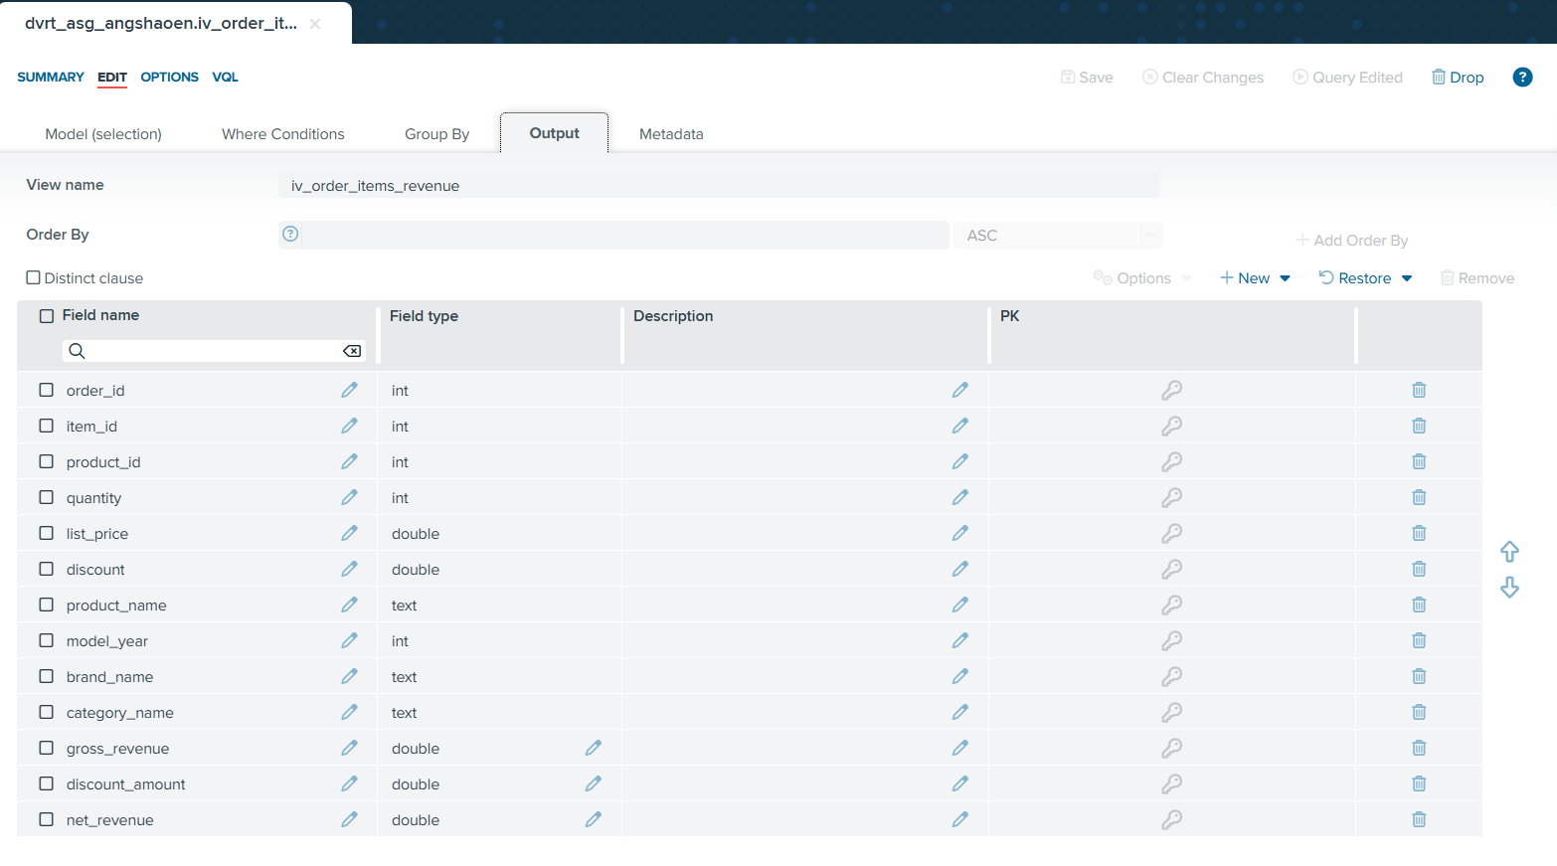
Figure 21. Final output for iv_order_items_revenue

iv_sales_fact (Unified analytic dataset)
Finally, iv_sales_fact combines the order-level features with the item-level revenue measures, producing one consolidated dataset that can be aggregated across store/location, time, brand, and category. This enables consistent KPI computation for the final view and aligns directly to the exploratory questions.

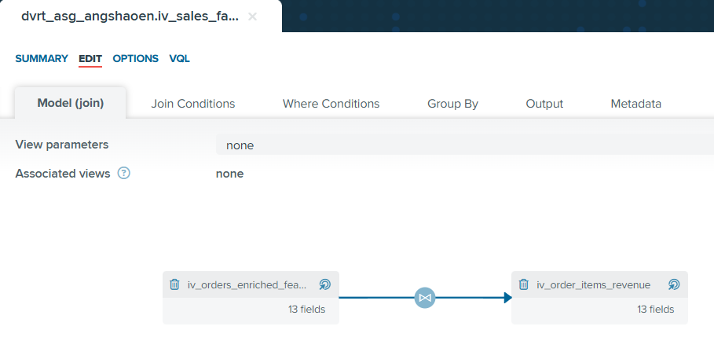
Figure 22. Join model for iv_sales_fact

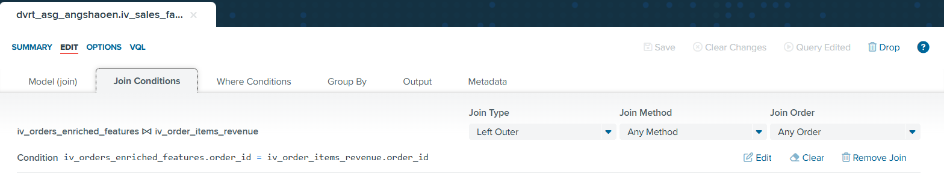
Figure 23. Join conditions for iv_sales_fact

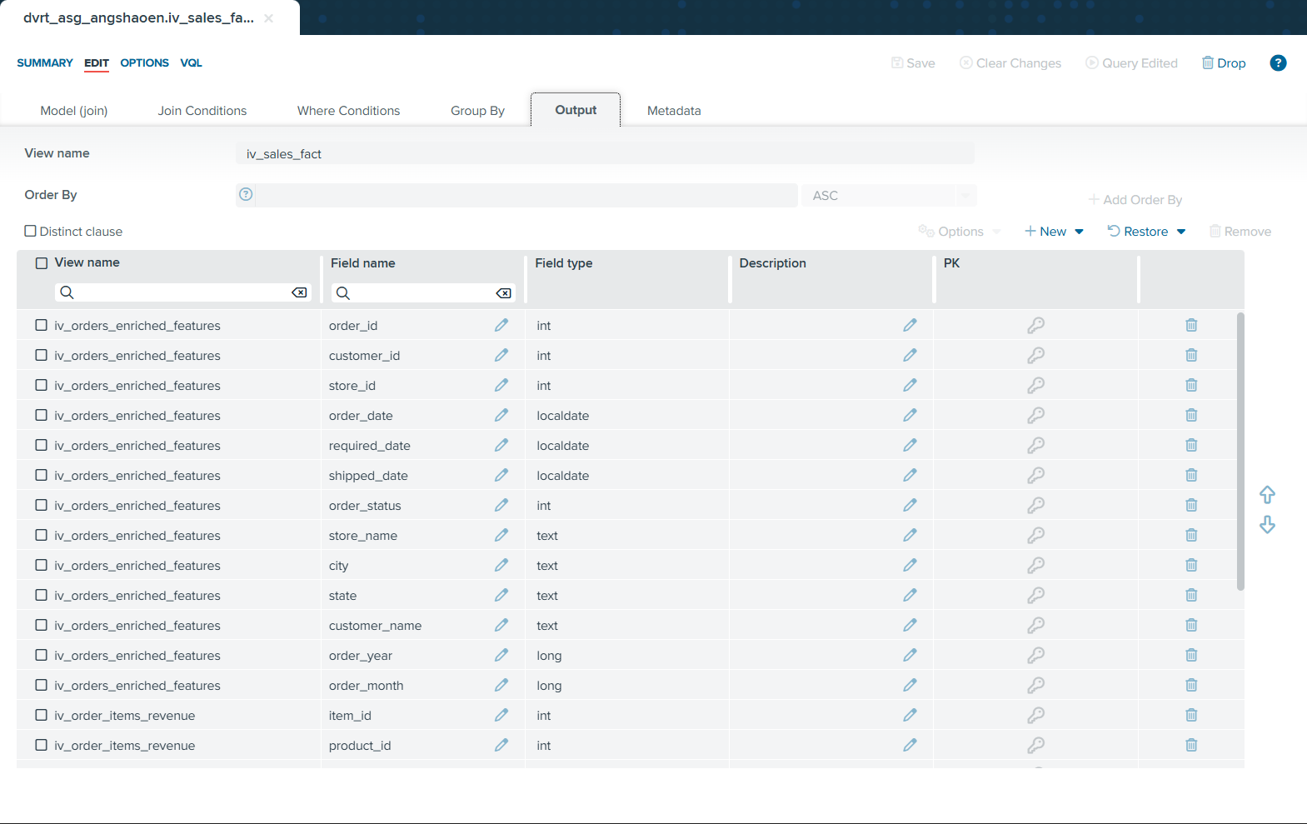
Figure 24. Final output for iv_sales_fact (Part 1)

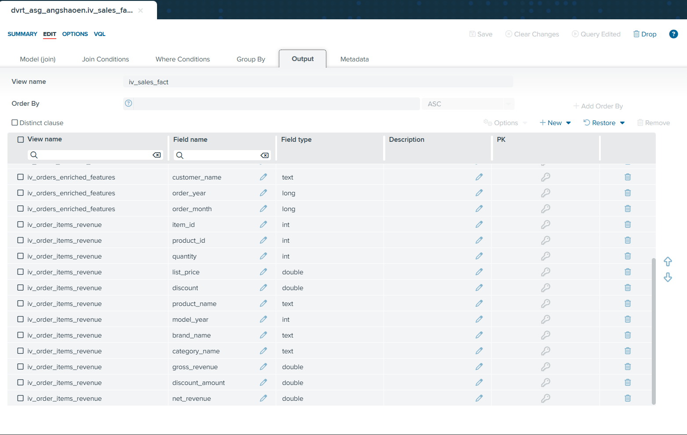
Figure 25. Final output for iv_sales_fact (Part 2)

Why was the feature engineering done in the Final Reporting View (RV) instead of the Integrated Views (IV)?
For me, in my solution, the Integrated Views were designed to stay close to the transactional grain and focus on integration + standardisation. Keeping IVs at the lowest useful grain makes them reusable for multiple downstream use cases and avoids locking the data into a single reporting structure too early.

The Final Reporting View, on the other hand, is intentionally the business reporting layer. The RV is where the dataset is transformed into aggregated monthly KPIs by the required analysis dimensions.
Performing feature engineering at the RV level is appropriate because:
- These metrics depend on aggregation
KPIs such as total revenue, unique customers, average order value, and discount rate only make sense after grouping by the reporting dimensions. If they were computed in an IV first, they would either be incorrect at row-level or force the IV to become aggregated too early.
- It avoids duplication and conflicting KPI definitions
If KPIs were derived across multiple IVs, different views might compute the “same KPI” slightly differently. Centralising KPI formulas in the RV ensures one authoritative definition for all stakeholders.

- It improves performance and maintainability for business reporting
Aggregation is done once in the RV, producing a compact monthly dataset suited for self-service analytics and the REST API. If aggregation were done earlier, it could create multiple large, aggregated views and make changes harder.

4. Final Integrated View
The final report view (RV), final_sales_performance_rv, was created as the business-ready dataset for stakeholder reporting and downstream consumption.


Figure 26. Final Report View (RV) created under 04_final_views as final_sales_performance_rv

Contributing Source Files
The RV is ultimately derived from all seven original CSV files: brands, categories, customers, orders, order_items, products, and stores. The core transaction grain originates from orders and order_items, while products, categories and brands provide product hierarchy for grouping, and stores/customers provide organizational and customer dimensions for analysis.

Why All Seven Files?
Using all seven ensures the RV captures both operational facts and the descriptive dimensions required by store managers, sales operations, and product managers. This exceeds the minimum requirement of 5 data sources and 3 CSV files in the final RV.

Aggregation Design (Grain)
The RV is aggregated by seven key dimensions that enable comprehensive multi-dimensional analysis:
Grouping Dimensions (GROUP BY)
- order_year – Enables year-over-year trend analysis
- order_month – Supports seasonal pattern identification
- state – Geographic performance comparison at state level
- city – Enables city-level market analysis
- store_name – Individual store performance tracking
- brand_name – Brand contribution analysis
- category_name – Category-level demand patterns

This grain was selected to balance detail and usability—it enables time-series trend analysis, cross-store comparison, brand and category-level performance monitoring without forcing stakeholders to work with raw item-level data. The addition of brand_name and city dimensions provides deeper insights than the initial design.

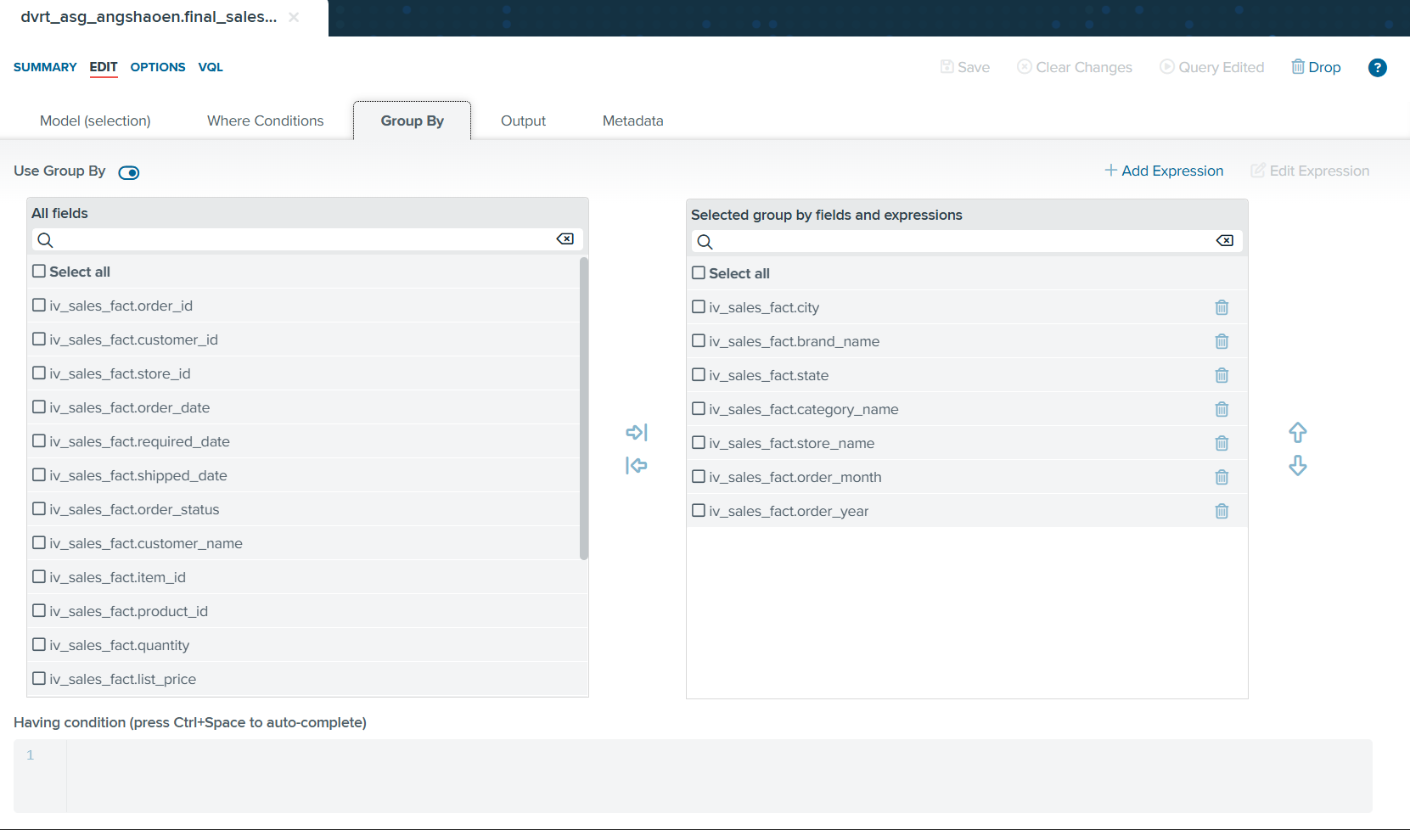
Figure 27. Aggregation (Group By) configuration for final_sales_performance_rv

Key Performance Indicators (KPIs)
The RV exposes three tiers of business metrics, progressing from raw aggregates to sophisticated ratios:

Tier 1: Core Aggregated Metrics
These foundational KPIs directly aggregate transactional data:
- total_net_revenue = round(sum(net_revenue), 2) – Total revenue after discounts
- total_gross_revenue = round(sum(gross_revenue), 2) – Revenue before discounts
- total_discount_amount = round(sum(discount_amount), 3) – Total discounts given
- total_units = sum(quantity) – Total units sold
- total_orders = count(order_id) – Number of transactions
- unique_customers = count(customer_id) – Distinct customer count
- avg_discount = round(avg(discount), 3) – Average discount rate
- avg_selling_price = round(sum(net_revenue)/nullif(sum(quantity), 0), 2) – Revenue per unit

Tier 2: Business-Ready Ratio KPIs
These calculated metrics provide deeper business insights by combining the core aggregates:
- discount_rate = sum(discount_amount)/nullif(sum(gross_revenue), 0) – Proportion of revenue lost to discounts
- avg_order_value = round((sum(net_revenue)*1.0)/nullif(count(DISTINCT order_id), 0), 2) – Average revenue per transaction
- orders_per_customer = count(order_id)/nullif(count(customer_id), 0) – Purchase frequency indicator
- net_revenue_per_customer = round(sum(net_revenue), 2)/nullif(count(customer_id), 0) – Customer value metric
- avg_units_per_order = round((sum(quantity)*1.0)/nullif(count(DISTINCT order_id), 0), 2) – Basket size indicator

Formula Design Rationale
All ratio calculations use nullif() to prevent division-by-zero errors, ensuring the view remains robust even when aggregating sparse data. The *1.0 multiplication in certain formulas ensures floating-point division for accurate decimal results. Rounding is applied consistently to maintain professional presentation standards.

How These KPIs Answer the Exploratory Questions
KPI Alignment with Business Questions
- "Which products and categories generate the highest net revenue?"
→ Answered by: total_net_revenue grouped by category_name and brand_name
- "How does sales performance differ across stores and over time?"
→ Answered by: total_net_revenue, total_orders, total_units grouped by store_name, state, city, order_year, order_month
- "What is the impact of discounts on net revenue?"
→ Answered by: discount_rate, total_discount_amount, comparison between total_gross_revenue and total_net_revenue
- "Which brands contribute most significantly to overall sales?"
→ Answered by: total_net_revenue, total_units grouped by brand_name
- "How do customer purchasing patterns vary?"
→ Answered by: orders_per_customer, net_revenue_per_customer, avg_units_per_order, unique_customers
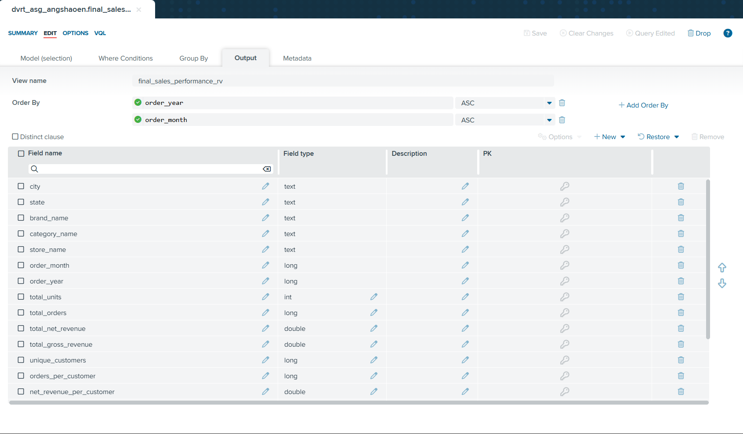
Figure 28. Output schema of final_sales_performance_rv (Part 1)

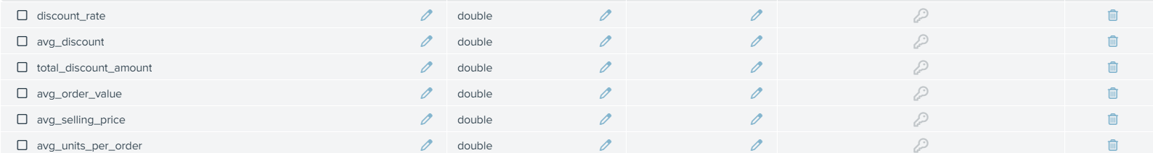
Figure 29. Output schema of final_sales_performance_rv (Part 2)

5. REST or SOAP Deployment
To enable lightweight consumption of the final reporting dataset by downstream users and applications, the final_sales_performance_rv reporting view was published as a REST web service. While Denodo supports both REST and SOAP services, REST was selected because it aligns better with modern analytics workflows and self-service usage: it is simpler to call from dashboards or scripts, supports multiple output formats easily, and has lower overhead than SOAP’s XML-based messaging.

Why REST over SOAP?
REST Advantages
- Lightweight HTTP-based interface
- Multiple output formats (HTML, XML, JSON)
- Suitable for browser-based exploration
- Simple integration for business users
- Ideal for read-only reporting scenarios
- Lower complexity for non-technical stakeholders
SOAP Limitations
- XML-only responses (heavier payload)
- More complex setup and integration
- Overkill for simple data retrieval
- Requires WSDL understanding
- Not browser-friendly
- Unnecessary for this use case

Business & Stakeholder Context
The primary stakeholders identified in this use case, the store managers, sales operations teams, and product managers, require read only access to aggregated sales performance metrics for monitoring, comparison, and trend analysis. These stakeholders typically consume data through dashboards, lightweight applications, or ad-hoc browser access rather than through tightly coupled enterprise systems.
As such, the chosen service interface must prioritize simplicity, accessibility, and low integration overhead, while still ensuring secure and reliable data access.

REST Service Configuration
A new REST web service (sales_performance_rest) was created under the 05_data_service folder to clearly separate service artifacts from the modeling layers.


Figure 30. Overview of data service

The final reporting resource (final_sales_performance_rv) was added to the service under the Resources tab, ensuring the endpoint exposes the business-ready aggregated output rather than raw transactional views.

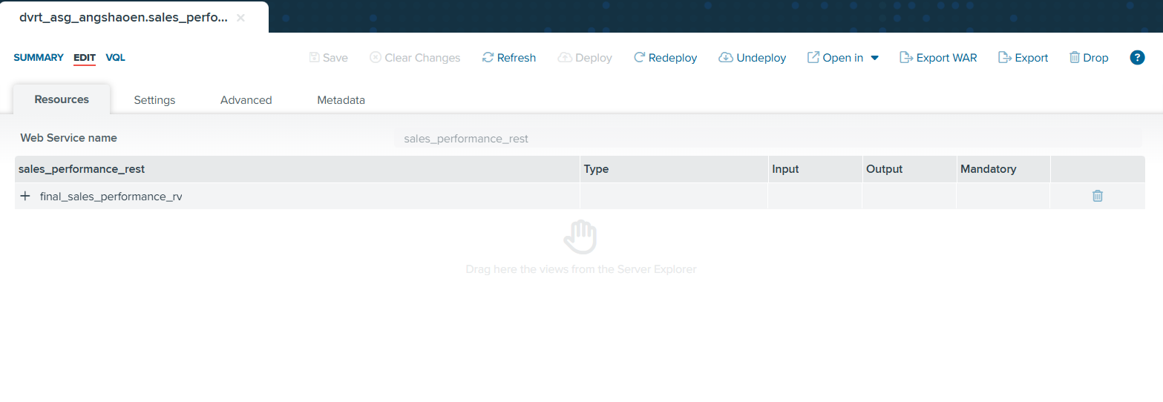
Figure 31. Selecting Final Report View for REST web service

Security Configuration
Authentication was configured using HTTP Basic with VDP, delegating access control to Denodo's server-side security and ensuring only authenticated users can consume the service.

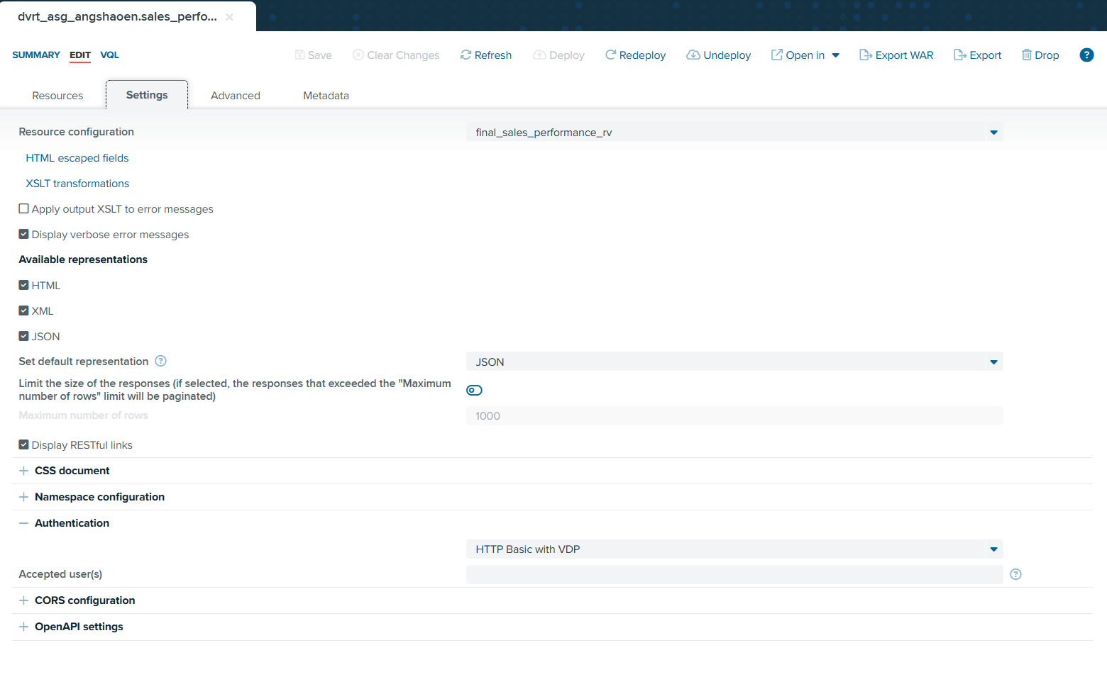
Figure 32. REST settings

Service Deployment
After configuration, the REST service was deployed using the Web Services Container management interface. Successful deployment confirms the service is active and accessible via the generated context path.

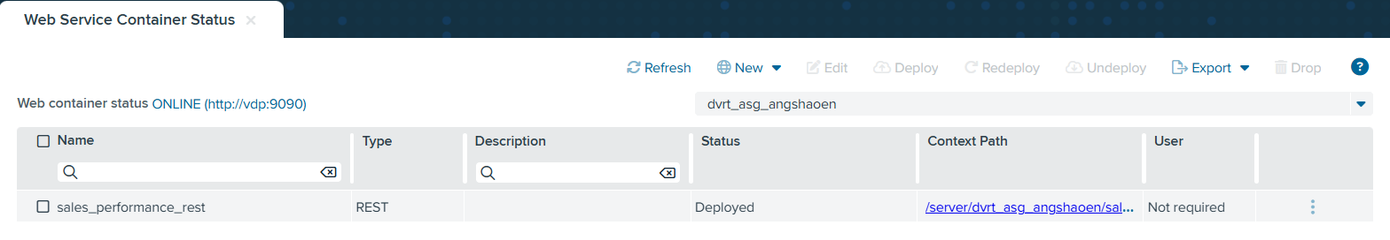
Figure 33. Deploying the REST web service

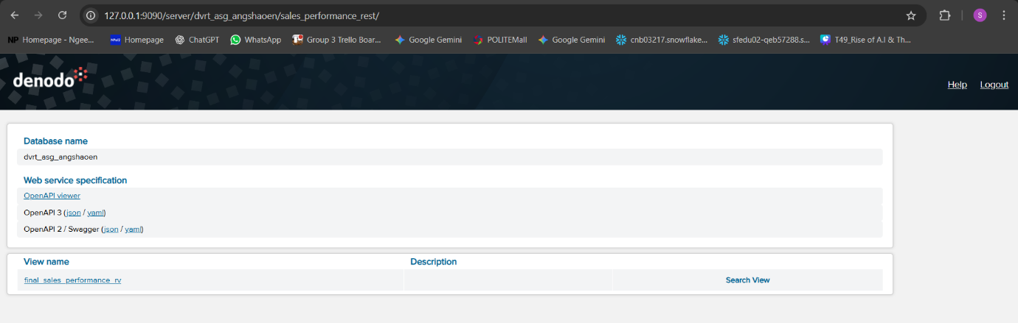
Figure 34. REST web service landing page for sales_performance_rest

Testing and Validation
The resource output was tested in the browser to confirm that the REST service returns the expected aggregated sales performance dataset and that the view is usable for analysis and reporting.
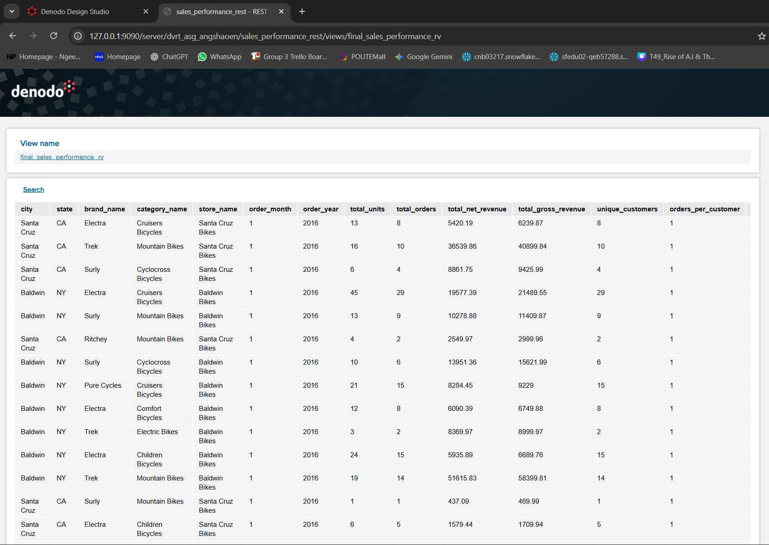
Figure 35. Browser preview of final_sales_performance_rv exposed via the REST service

Deployment Outcome
This deployment step completes the virtualization workflow by enabling external consumption of the integrated reporting layer without duplicating or physically moving the underlying data. Stakeholders can now access consistent sales performance metrics through standard HTTP requests.

6. Summary and Further Improvements

Summary of Achievement
This assignment demonstrated an end-to-end data virtualization workflow in Denodo to deliver a unified sales performance dataset for a bicycle retailer. Starting from seven raw CSV sources (brands, categories, customers, orders, order_items, products, and stores), I created a layered view architecture consisting of:
- Datasources (ds_*) – CSV file connections
- Base views (bv_*) – Standardized, typed views
- Integrated views (iv_*) – Enriched and calculated views
- Final reporting view – Aggregated business metrics
This design improves maintainability and traceability by separating ingestion, cleaning/standardization, enrichment, and business reporting logic into clear stages.

Key Learning Outcomes
A key learning outcome was understanding how Denodo supports "logical integration" through joins, derived fields, and grouping without physically moving data. Building the integrated layer reinforced the importance of:
- Selecting the correct grain (order-level vs item-level)
- Enforcing consistent datatypes for join keys and measures
- Deriving business metrics (gross revenue, discount amount, net revenue) in the right layer to avoid duplicated calculations
- Understanding trade-offs in aggregation granularity
Deploying the final view as a REST service also highlighted how Denodo can operationalize virtual datasets for downstream consumption, allowing both browser-based exploration and API-based access through standard HTTP interfaces.

Further Improvements
There are several potential improvements that could further strengthen the solution:
High Priority
- Performance Optimization – Apply selective filters and projection early; consider caching or materialization strategies for frequently accessed aggregates
Medium Priority
- Extended Time Intelligence – Add quarter/week dimensions, rolling averages, and year-over-year comparisons
- Customer Segmentation – Distinguish new vs. returning customers, create customer lifetime value metrics
- Product-Level Detail – Provide drill-down capability to individual SKU performance while maintaining aggregated default view
Low Priority
- API Documentation – Enable OpenAPI/Swagger documentation for external API consumers
- Advanced Security – Implement role-based access control with different permission levels for different stakeholder groups
- Data Dictionary – Create comprehensive documentation for all final measures and dimensions to ensure consistent interpretation across stakeholders

Conclusion
This assignment successfully demonstrated the power of data virtualization in creating agile, maintainable data integration solutions. By leveraging Denodo's capabilities, I transformed fragmented operational data into a unified, business-ready reporting layer that serves multiple stakeholder groups without the overhead of traditional data warehousing approaches. The layered architecture ensures flexibility for future enhancements while the REST deployment provides accessible, standards-based consumption for downstream applications and users.

